Phenocam Installation Instructions (June 2015)
Andrew Richardson (arichardson@oeb.harvard.edu)
Miriam Johnston (johnston.miriam@gmail.com)
Stephen Klosterman (klosterman@fas.harvard.edu)

Earlier versions by:
Cory Teshera-Sterne, Elizabeth Felts, Stephen Klosterman, Andrew Richardson
Thank you for your help with the PhenoCam network! Here are some installation instructions for the StarDot NetCam SC. The camera is pre-configured to automatically take two images (one color visible-wavelength image, and one monochrome visible+NIR image) and upload them to the PhenoCam FTP server every 30 minutes. We do not stream live imagery over the web, and individual uploads are only ~400 KB, so bandwidth requirements are relatively minor.

We have fully configured and tested your camera. But, we recommend that you connect the camera to your own network, on the ground first, and verify that it is uploading imagery to the PhenoCam web page (the latest image will always be displayed at
http://klima.sr.unh.edu/data/latest/sitename.jpg
where sitename is the name of your site, and is printed on the top of your camera; if you need to know the MAC address of your camera, it is the serial number printed on the label on the bottom of the camera). Note that images may take 15–30 minutes to appear.
Camera location:
- Phenology is one goal, but we'd also like good-looking pictures.
- If possible, we'd prefer that the camera be pointed north (to minimize lens flare and shadowing).
- We'd prefer to have a horizon in the picture, but the picture should be more than 50% canopy and less than 50% sky; the ideal mix is about 20% sky, 80% canopy).
- We'd prefer that the camera point somewhat below the horizontal to obtain maximum canopy coverage and also spatial integration (a mounting height of 5-10 m above the canopy is generally good, but the specifics may depend on the nature of your tower, length of cables, etc.).
- The figure below (left) illustrates the general set-up; at this time, we are not advising the inclusion of a reference panel. We are open to suggestions for a robust, inexpensive, weatherproof design that is a good diffuse reflector (to minimize BRDF effects).
- The sample image from the Harvard Forest, shown below (right), illustrates a field of view that is more or less ideal.

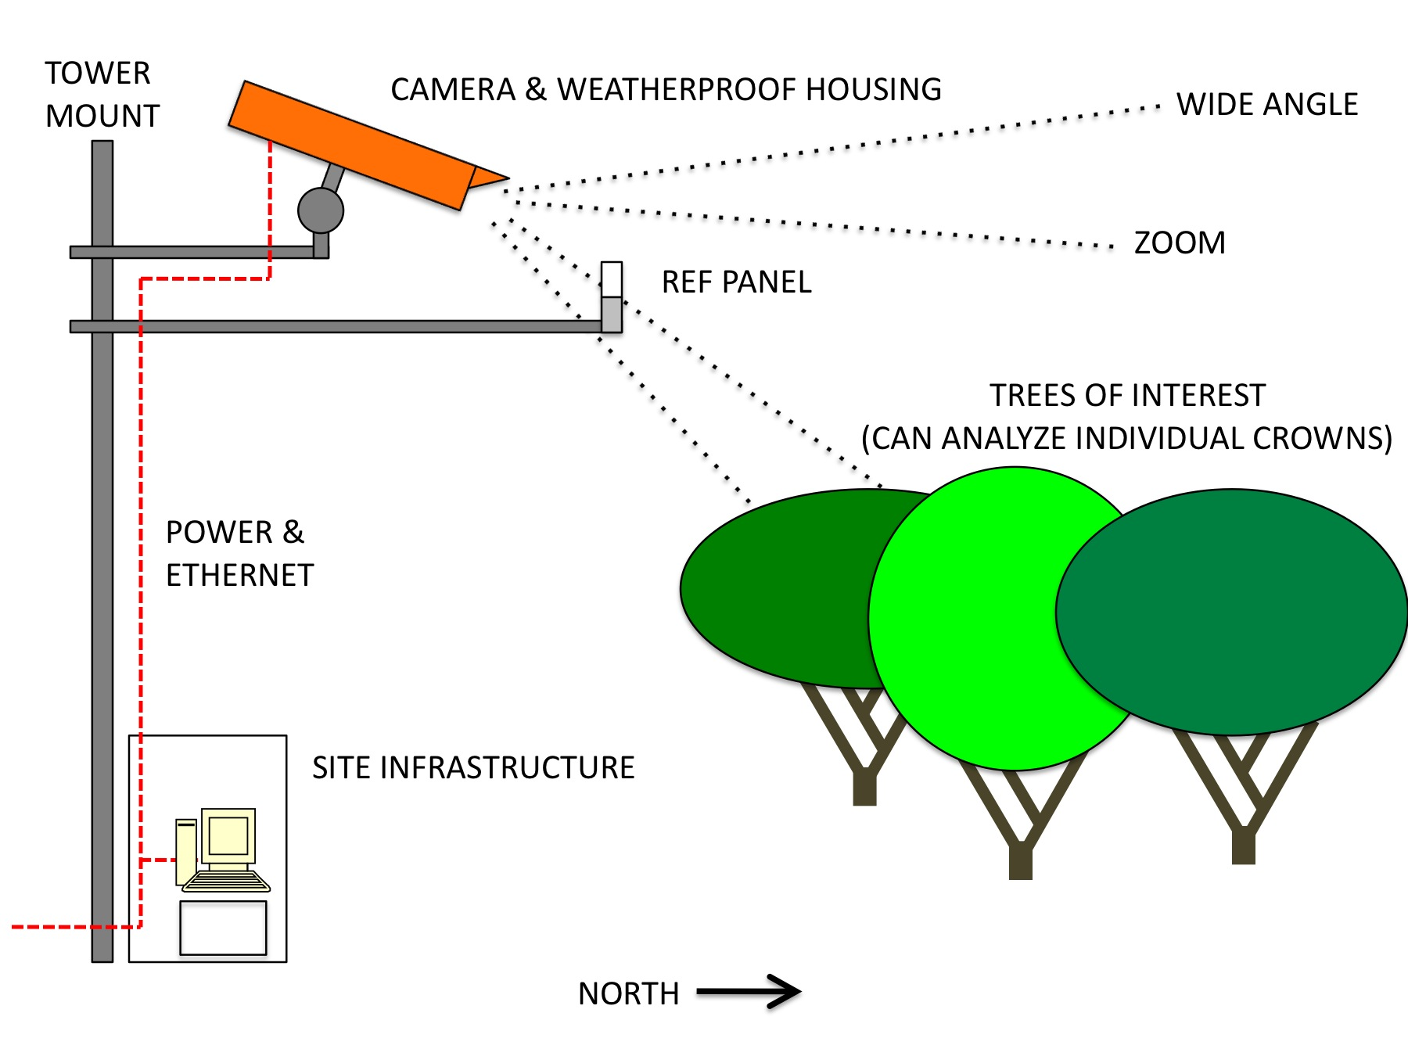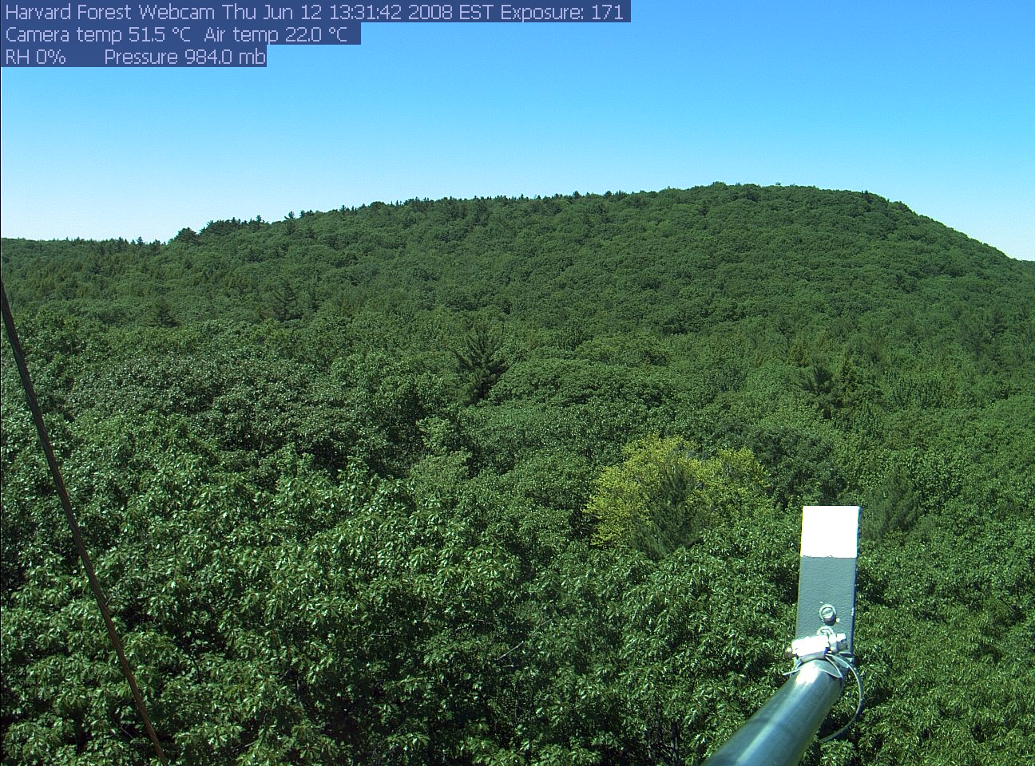
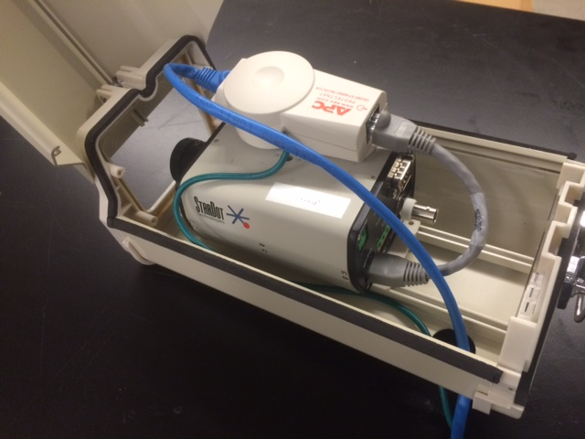
Connecting the camera:
- Install the housing bracket and housing following the above “Camera location” guidelines. There is a sliding mount inside the housing to which the camera attaches with a short screw. This is usually a ¼-20 screw (which is included with the housing), but some cameras have shipped recently with M6 threads (if we sent you a camera with M6 threads, we will have also included an M6 screw). The sliding mount snaps in to the rails on the bottom of the housing.
- We use an APC ethernet surge protector to help prevent damage in the event of lightning. If the surge protector is placed on top of the camera as shown below, it will just fit inside the housing. Please use the short grey cable included with the surge protector (please see instructions on the back of the surge protector packaging; note the correct orientation of the surge protector as shown in the photo to the right) to connect the surge protector to the camera's ethernet socket. The green wire on the surge protector should be connected to ground (if you are mounting on a well-grounded tower, we recommend using a hose clamp to secure the ground wire directly to the tower itself)
- If your site has AC line power, then we will have provided you with a POE (power-over-ethernet) injector, which plugs into the wall and which allows power to the camera to be sent over the standard ethernet (cat 5, 5e, 6) cable (i.e., the blue cable in the picture above) which we have sent you. This is illustrated in the picture below (left). One end of the ethernet cable goes to the surge protector, the other to the “power+data out” socket on the POE injector. Then connect one end of a short Ethernet cable to the “data in” socket on the POE injector, and the other to your network hub. Then plug the POE injector into an electrical outlet.
- If your site uses DC power (solar, generator, etc.), then we will have provided you with a special combination ethernet/power cable (the white cable in the picture on the right, below). This eliminates the need for a separate power cable to the camera. The end with the male power jack goes to the camera (plug the power jack into the socket on the back of the camera, and plug the ethernet connector into to the surge protector). The end with the female power jack has a male jack with two terminals (marked + and -) attached. Run a wire from this jack to your battery bank (the red and black wires in the picture on the right). Before connecting power, however, plug the Ethernet connector into your network hub, as the camera requires an Ethernet connection when it is powered up.
- If necessary, please remember to remove the camera's lens cap before installing the camera! Note that the camera should be slid forward in its housing, so the lens is almost touching the window, to minimize the potential for reflections.

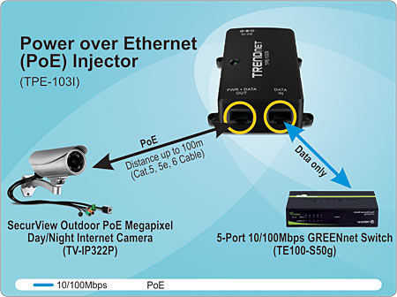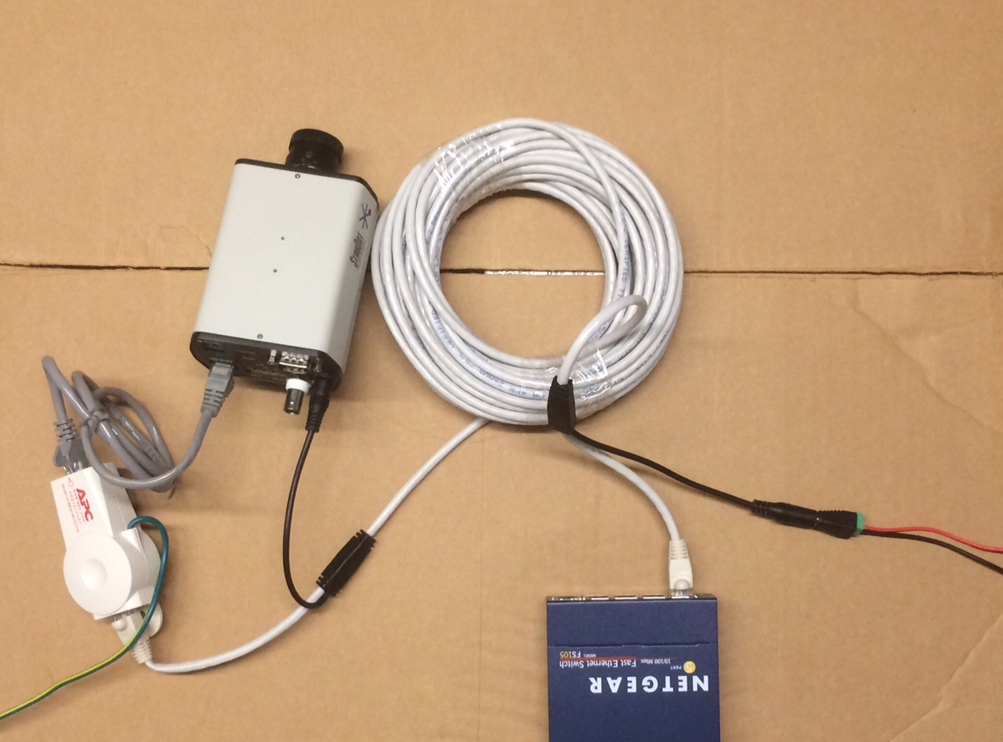
Test if the camera is on your network:
- Install StarDot Tools from the included CD (Windows only, sorry).
- Run the program and click "refresh".
- The camera should be detected and the camera’s IP address shown (you may have to run Tools as administrator in Windows, depending on your settings). See the Troubleshooting section below if the IP address is not automatically detected.
- Enter the camera’s IP address into your internet browser’s address bar; a page should load with a blue background and a live image from the camera.
Log in to the camera's configuration pages:
- Click the "config" link at the bottom of the live camera image
- Log in as user "admin", password "admin" (if we have changed the password on your camera, it will be printed on the top of the camera as “pw: xxxxx”. Note that if your camera is connected directly to the internet, and can be accessed from anywhere in the world, then it is essential that the password be changed to something that is secure).
- Please do not change any config settings! If the cameras are standard IR-enabled NetCams, they are configured to upload back-to-back IR and RGB images; changing the FTP settings in particular (or even clicking the box that says “FTP Upload”) will likely cause upload problems.
- If for some reason the camera needs to be reconfigured (please check with us first), the best way to do this is to use the PhenoCam Install Tool (PIT), which you can download here:
https://bitbucket.org/khufkens/phenocam-installation-tool
Focusing:
- Focusing works best on a sunny day with a nearby laptop connected to the camera's configuration pages. Cameras are focused in the lab before being shipped, but you will probably want to fine-tune the focus depending on the distance from the camera to the vegetation of interest. If you want to adjust the focus, this is best accomplished while viewing the camera image on a laptop. You will want to do this with the camera mounted on the tower so that you can verify that the field of view is as desired.
- The standard lens we recommend is the 6.2 mm, which is relatively easy to focus, as it has just a single focus knob. The 4-10 mm zoom lenses sold by StarDot can yield great images, but with zoom, iris, and focus, they are much more difficult to focus.
- On the camera's config pages, change "Resolution" to "688x480 NTSC Focus Mode" (last option in the drop-down under Image -> Processing) and hit "APPLY".
- Click on "Pop-up Live Image" in the upper right-hand corner to open a large image. In focus mode, only a fraction of the total image is displayed, but this way the refresh rate is very fast and it is quite easy to get the focus very sharp.
- Adjust the focus ring (it can be quite sensitive) so that the image is sharp. You may find it helps to focus on a specific object in the image – such as a branch. Tighten the screw on the focus ring when finished. Change the resolution back to its original value ("1296x960 QFULL*", see reference image below) and hit "APPLY".

Configuration Notes
Please check with us before making any changes to settings.
If the vegetation in the camera’s field of view is very dark, then the camera may over-compensate slightly and over-expose the rest of the image so that the vegetation is properly exposed. You can handle this in a few ways. One, include more sky in the image. Two, adjust the brightness level on the “Exposure” tab. Three, include more of the sky in the “Exposure Grid.” We can help you determine the optimum setting for your site.
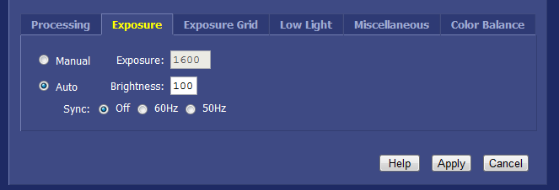
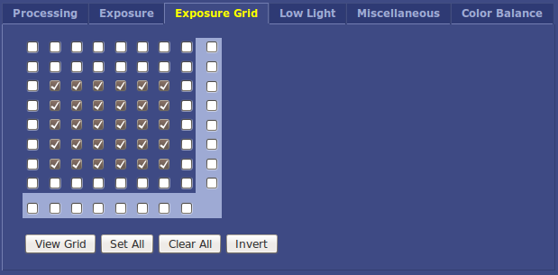
The only way to get good-quality data from your PhenoCam imagery is if the camera is set to Manual (also known as “Fixed”) color balance (also known as “white balance”). For the 1.3 MP and 5 MP StarDot NetCam SC, the values below (R: 385, G: 256, B: 330) are appropriate. The 3 MP camera and the NetCam XL both use different sensors and different values may be needed. Contact us to discuss.
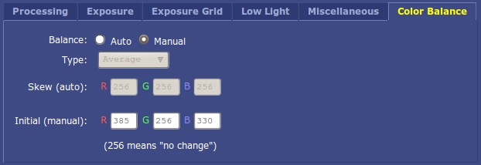
General Troubleshooting:
We recommend you keep an eye on the PhenoCam web page to check that images from your camera are updating regularly, that the window is not dirty or obscured, and that the camera field of view is still as desired (e.g., the housing has not shaken loose). We also monitor the frequency of image uploads from each site; if it has been several days since the last image, we will contact you by email and ask you to help get the camera back online. Many problems can be fixed simply by temporarily unplugging the ethernet cable to the camera and at the same time cycling the camera's power, being sure to plug in the Ethernet cable before the power if these are separate connections. You should also check that the green light on the front of the camera is on, and that the status light on the LAN router socket where the camera is connected is flashing green as well.
- During initial installation, the camera is configured to be automatically assigned an IP address via DHCP; depending on your network settings you may need to consult with your IT person regarding IP addresses. If needed, the MAC address is printed on the underside of the camera.
- If you encounter issues, try to connect to the camera in your browser. Depending on your network, the IP address assigned to the camera may change periodically; run the StarDot Tools program if necessary. If you can't find the camera's IP address this way, let us know: we can check on the PhenoCam server to find the last address the camera uploaded from.
- If you can connect to the camera in your browser, and live images are being displayed, then everything is probably ok. If you cannot find the camera on your network, or cannot connect to the camera in your browser, then the camera may need to be sent back for repairs; contact us.
- If you can connect to the camera in your browser, but images are still not uploading properly to the PhenoCam web page, the last thing to try is to connect to the camera via Telnet and look at the log files. The camera is actually a compact stand-alone computer, running its own Uclinux operating system. From a terminal window, connect to the camera:
>Telnet (enter: camera's ip address)
>User: (enter: admin)
>Password: (default is admin, but see notes on page 3)
From the Uclinux prompt, type "cat /var/log/syslog" and then "dmesg"; these will output quite a few lines of text to your screen. Please copy the output into an email to us.
From the Uclinux prompt, type "logout".
Note: If you are running a post-XP Windows operating system, Telnet is not available by default; we recommend using the lightweight third-party program PuTTy, or you can consult Microsoft's help pages to turn on this function.
If additional troubleshooting is required, we will provide instructions as necessary.
Feedback and Corrections
This document is a work in progress. We appreciate any suggestions for improvement to, or clarification of, the above instructions.
Thank you again for your help with the PhenoCam project.

